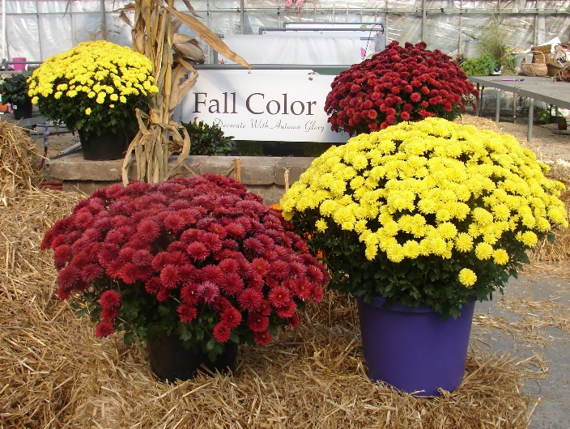
Your Name
And Info Here
Contact:

We are having a Fall Flower Fundraiser!
Enjoy beautiful Fall flowers and support our group! These are special gifts that celebrate this great time of year. Ring in the new football season and fall harvest with our beautiful plants!

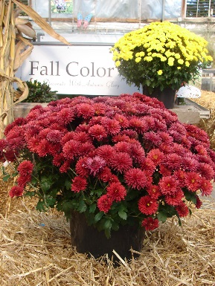
Flowering Mums: Vibrant mums, available in red and yellow. Mums are grown in 9x6 mum pans, priced at $ PUT PRICE

How many Red Mums:______

How many Yellow Mums:______

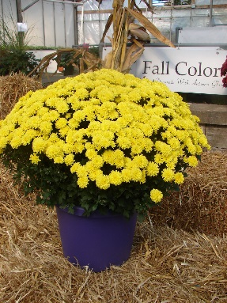
‘Think Football’ Mums: Large golden mums in a 2 gallon, purple pot, priced at $ PUT PRICE HERE

How many ‘Think Football’ Mums:_______

Total amount for this order:
Customer Name:
Customer Contact info:

Note: These lovely plants will be delivered on DATE: PUT DATE HERE
to be picked up PUT LOCATION HERE
Pay by: PUT PAYMENT INFO HERE

