Spring Fundraiser!
Support our group with some beautiful spring and Mother’s Day Flowers! We are offering a mixed flower planter, geraniums, hanging baskets, flowering annuals, herbs and veggies. Info you need to know: Order by April ____________ payment by_____________ pick up date and location is ______________________________________________________________________

Hanging Baskets! $19.99
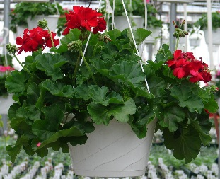
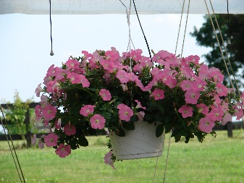
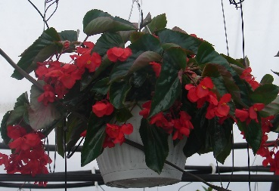
Geraniums for mixed light, petunias for sun, begonias for shade, and colorful mixed annuals.
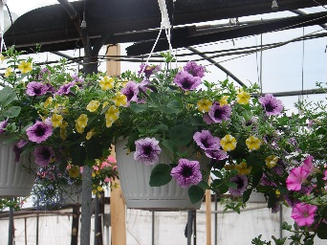
Please note: all photos are for illustration purposes actual colors may vary.

Edible herb and veggies, in 4” pots $2.99:
Basil, parsley, red tomato, sweet pepper, hot pepper

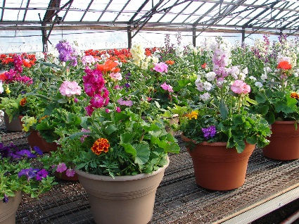
Mixed Planter $19.99 10” round, Geranium and mixed annuals
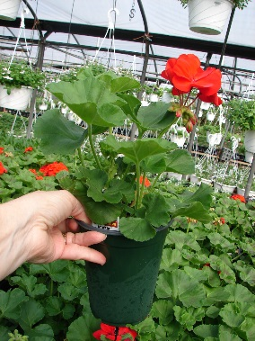
Flowering Geraniums $4.99
Available in red, white, or pink

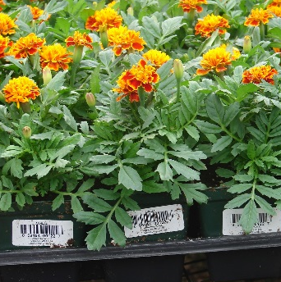

Flowering Assorted Annuals 4” pots $1.99
Such as marigolds, begonias, and others

